**Mini Project**

**on**

**Home Automation**

**Submitted**

**BY**

**Mr. Aditya Balki**

**Semester/Section: 6th/B**

**Roll No: 133**



**April, 2022-23**

**Department of Computer Technology**

**YESHWANTRAO CHAVAN COLLEGE OF ENGINEERING, Nagpur**

(An Autonomous Institution Affiliated to Rashtrasant Tukadoji Maharaj Nagpur University)

**Table of Contents**

**Title Page No.**

1. **Introduction………………………………………….**
2. **Implementation Methodology ………………………**
3. **Architecture and Design…………………………….**
4. **Results………………………………………………..**
5. **RMMM plan…………………………………………**

**References………………………………………………**

**Chapter 1 – Introduction**

Home automation is an exciting and rapidly growing field that allows homeowners to operate and control various home functions and devices with the help of technology. Whether you want to control the lighting, temperature, security or other features in your home, home automation can help you get there.

The first step to getting started with your home automation mini project is to identify the problem you want to solve. Want to control the lighting or temperature in your home? Want to automate your home security system? Once you have a clear idea of the problem you are trying to solve, you can start looking for different home solutions that might be appropriate.

There are many home automation systems and platforms available, from popular options like Amazon Alexa and Google Home to more specialized systems like SmartThings and Home Assistant. Explore features, compatibility, and price differences to determine which will be best for your project.

Once you have home automation in mind, you can start thinking about specific tools you will use. Smart lights, thermostats, security cameras, and door locks are popular options, but there are many other accessories to choose from. Consider each device's capabilities and compatibility to ensure they work well with the home automation system you choose.

After you receive your equipment, you need to plan how you will install them. This may include setting up your home automation system, setting up personal devices, and establishing rules or procedures for performing certain tasks. Before you start setting everything up, make sure you have a clear plan.

Finally, it is important to test your home automation system and make sure everything is working as expected. You may need to tweak or tweak settings to get everything working. Do not be afraid to iterate and make changes as needed to get the best results.

**Chapter 2 – Implementation Methodology**

To implement the above goals, the following methodology needs to be followed:

1. Planning: Define the resources and needs of the project, including the equipment and systems to be used, the work to be done, and the completion time frame. Create a project plan outlining the steps to be taken and the resources needed.
2. Design: Design detailed specifications for home electronics, including equipment setup, network structure, and interface management. This should include a clear understanding of the software and hardware requirements as well as any necessary integration with existing systems.
3. Purchasing: Purchasing the necessary hardware and software equipment for project and design-based systems.
4. Installation: Install the device and set up the network infrastructure according to the design. Configure software and hardware as needed.
5. Integration: Integration of home automation system with any existing system such as HVAC, lighting or security. This may require special programming or configuration.
6. Testing: Testing a system both individually and as a whole to ensure that it functions as intended.
7. Make sure that all functions are working properly and that the system is reliable and safe.
8. Training: Train users on the operation of the system, including any required software interfaces or control panels.
9. Maintenance: Create a plan for regular maintenance of home automation systems, including software updates, hardware and troubleshooting.

**Chapter 3 – Architecture and Design**

**3.1 Architecture:**

The home automation system will have three elements: ESP32 microcontroller, web interface and Android app. The ESP32 will be the controller of the device and the sensors connected to it, while the web interface and Android app will allow users to control the system from their web browser or mobile device.

**3.2 Design:**

1. ESP32 Microcontroller: ESP32 will be the core of the home automation system. It will be responsible for communicating with the web interface and Android app, as well as controlling the devices and sensors connected to it. The ESP32 will run firmware that allows it to interact with connected devices and sensors and communicate with web interfaces and Android apps using web protocols (such as HTTP) and Wi-Fi.
2. The app will display the status of devices and sensors and will allow users to turn sensors on or off, adjust settings and view information from sensors.
3. Sensors and Devices: Devices and sensors to be connected to the ESP32 will depend on the specific requirements of the home automation system. Examples of devices that can be connected include lights, thermostats, door sensors and security cameras. Examples of sensors that can be connected include thermometers, thermometers, and thermometers.
4. Network Infrastructure: The home automation system will rely on Wi-Fi network infrastructure to communicate between ESP32, web interface and Android app.
5. Network infrastructure must be reliable and secure to ensure systems are always available and user data is protected.

**Chapter 4 – Results**

1. Make it easy: With a home automation system, users can control their devices and sensors without interacting with their bodies. This can bring more convenience and save time.
2. Energy saving: Users can reduce energy consumption and save energy costs by using a home automation system to control lights, temperature and other appliances.
3. Enhanced Security: Home automation can include security features such as motion sensors, security cameras, and smart doors to provide security, safety, and peace of mind to users.
4. Better accessibility: Home automation systems can provide better accessibility for people with disabilities by allowing them to more easily control devices and sensors in their home.
5. Personalization: With home automation systems, users can customize their settings and preferences to suit their unique needs and lifestyles.
6. Data Insights: Home automation can provide users with valuable information about energy consumption and usage, enabling them to make informed decisions about their behavior and save money.

Screenshots :

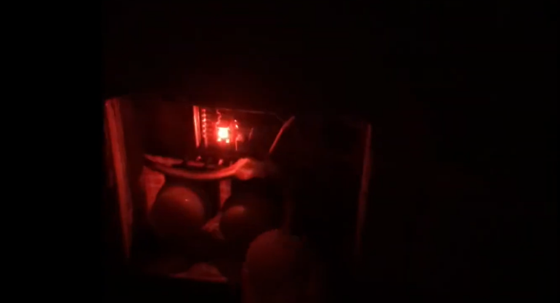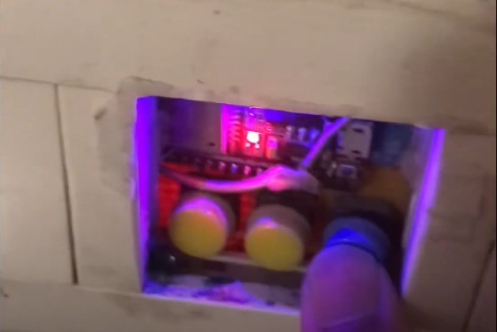

Website Screenshot:

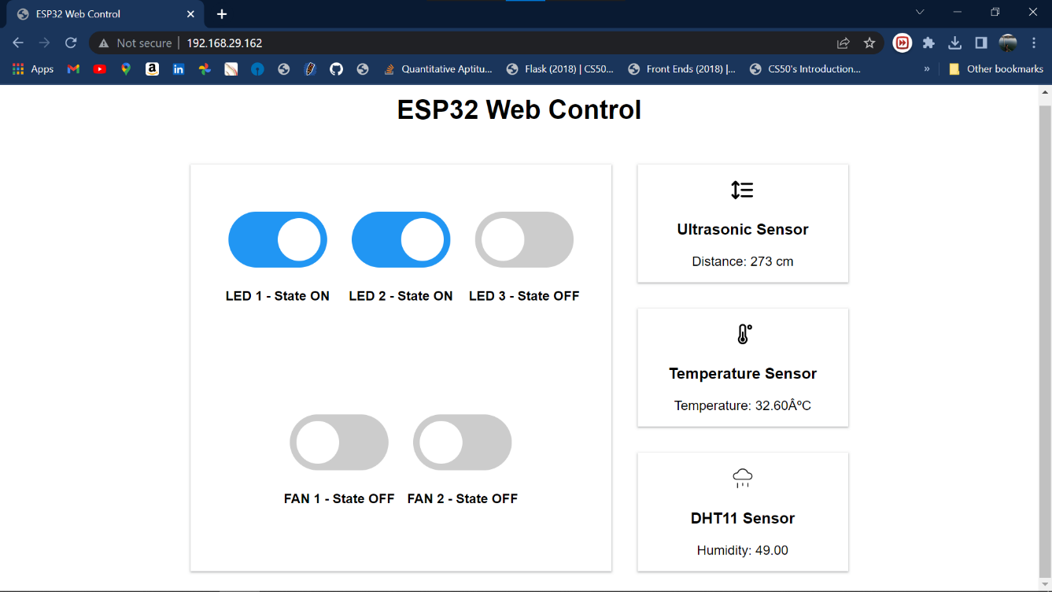

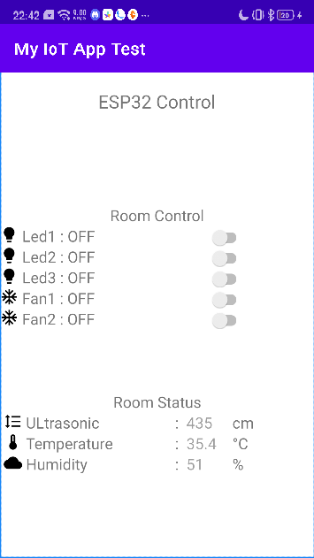App Screenshot:

**Chapter 5 – RMMM Plan**

|  |  |  |  |
| --- | --- | --- | --- |
| **Risk Information Sheet** | | | |
|  | | | |
| Risk ID: R001 | 04/04/23 | Prob.: High | Impact: Moderate |
| **Description:** Hardware failure | | | |
| **Refinement/context:** Technical risk | | | |
| **Mitigation/monitoring:**  Use reliable hardware and perform regular maintenance. Monitor the hardware performance regularly. | | | |
| **Management/contingency plan/trigger:**  In case of a hardware failure, switch to backup system or alternative solution. | | | |
| **Current status:**  Not occurred yet | | | |
| **Originator:** | | **Assigned:** | |

|  |  |  |  |
| --- | --- | --- | --- |
| **Risk Information Sheet** | | | |
| Risk ID: R002 | 12/04/23 | Prob.: High | Impact: High |
| **Description:** Hacking and unauthorized access | | | |
| **Refinement/context:** Security risk | | | |
| **Mitigation/monitoring:**  Use strong passwords and secure authentication methods. Implement data encryption and secure data storage. Conduct regular security audits and vulnerability assessments. | | | |
| **Management/contingency plan/trigger:**  In case of a security breach, follow incident response procedures to contain the breach and prevent further damage. Notify all affected parties and provide guidance on how to protect themselves. | | | |
| **Current status:**  Not occurred yet | | | |
| **Originator:** | | **Assigned:** | |

|  |  |  |  |
| --- | --- | --- | --- |
| **Risk Information Sheet** | | | |
| Risk ID: R003 | 14/04/23 | Prob.: Low | Impact: High |
| **Description:** User resistance | | | |
| **Refinement/context:** User adoption risk | | | |
| **Mitigation/monitoring:**  Provide clear instructions and user manuals. Offer training sessions to users. Conduct usability testing and make improvements based on user feedback. | | | |
| **Management/contingency plan/trigger:**  In case of low user adoption, conduct a thorough analysis to identify the reasons and develop a plan to address them. Offer additional training or support to users if necessary. | | | |
| **Current status:**  Not occurred yet | | | |
| **Originator:** | | **Assigned:** | |

|  |  |  |  |
| --- | --- | --- | --- |
| **Risk Information Sheet** | | | |
| Risk ID: R004 | 14/04/23 | Prob.: Low | Impact: Moderate |
| **Description:** Fire | | | |
| **Refinement/context:** Environmental risk | | | |
| **Mitigation/monitoring:**  Install smoke detectors, fire alarms, and sprinklers. Have an emergency plan in place in case of fire. | | | |
| **Management/contingency plan/trigger:**  In case of a fire, follow emergency procedures and ensure the safety of all users. Evacuate the building if necessary. | | | |
| **Current status:**  Not occurred yet | | | |
| **Originator:** | | **Assigned:** | |

**Chapter 6 – References**

Visited URLs:

1. *https://ijarsct.co.in/Paper1176.pdf*

*"*Home Automation Using IOT” *(PDF).*

(Accessed on 01/04/2023 at 19:27 pm IST)

1. *https://en.wikipedia.org/wiki/Home_automation*

(Accessed on 01/04/2023 at 19:27 pm IST)

1. *https://projecthub.arduino.cc/*

(Accessed on 03/04/2023 at 20:05 pm IST)

1. [*https://circuitdigest.com/esp32projects#:~:text=ESP32%20is%20a%20tiny%20cheap,directly%20from%20the%20Arduino%20IDE.*](https://circuitdigest.com/esp32projects#:~:text=ESP32%20is%20a%20tiny%20cheap,directly%20from%20the%20Arduino%20IDE.)

(Accessed on 03/04/2022 at 21:27 pm IST)